POLICE VERIFICATION FORM

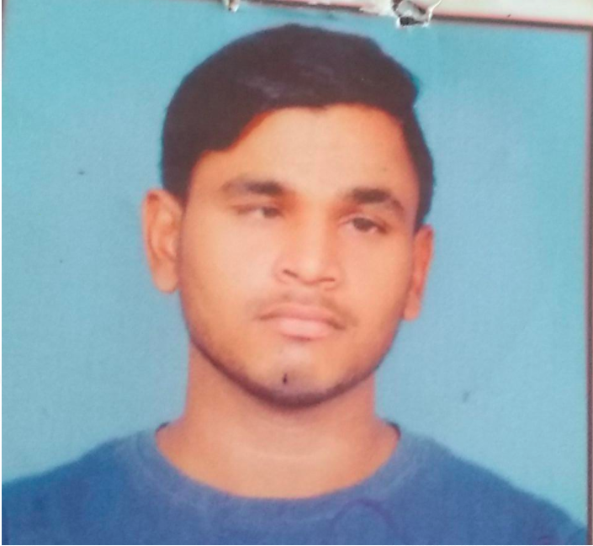
POLICE STATION – DEEH DISTRICT – RAEBARELI

DETAILS OF EMPLOYEE

- Name of the Employee – Pavan Kumar
- Father’s Name – Brahma Prasad
- Mother’s Name – Fula Devi
- Date of Birth – 21-09-1996
- Language Spoken – Hindi/English
- Permanent Address – Vill & Post Lodhwari

PS – Deeh District – Raebareli

State – Uttar Pradesh Mobile No. – 8601792047

- Details of identification proof – AADHAR CARD ( COPY ATTACHED )
- Local Address – Vill and Post Lodhwari PS – Deeh, Disstt – Raebareli 229310
- Any Criminals Recoreds –

S.H.O.
PS DEEH
DISST – Raebareli
UTTAR PRADESH

